2023/2024 Leadership Giving Circle

United Way of Haywood County

# 

|  |
| --- |
| **SILVER CIRCLE, CONTINUED** |
| George & Marleen Marshall |
| Dan & Deener Matthews |
| David & Leah Mehaffey  Teresa Mills |
| James B. Phelan |
| Maurice & Claire Phillips  Tom & Patsy Posey |
| Ricky & Kathy Sheppard |
| Bill & Treva Upton |
| Aleesa C. Williams |
| Deborah Wilson |
| Buddy & Jane Young |

**BRONZE CIRCLE**

|  |
| --- |
| Thomas F. Armstrong |
| John Boate |
| John & Jan Chicoine |
| Don & Denise Coleman |
| Melissa Collins |
| Michael Denman  Stephen Dettor  Michelle Deville  Anne Foster  Brent Franks |
| Lee Galloway &  Nancy Thompson  Dianne Goodgame |
| Wendy Hines |
| Jason Jahelka  Ronald Kidwell  Mallory King  Illia Kryvytskyi |
| John Jay & Arlene Mills |
| Jan Shuler Plummer  Gail Powell  Steven & Kristina Price |
| Sylvia Russell  Joseph Samble |
| Pat & Linda Stewart  Jim Thurman |
| Ann Whaley  Shelley White |
| Barry & Celesa Willett  Dylan Winchester  Anonymous Donors |

* * *

**ALEXIS DE TOCQUEVILLE**

Chuck Beemer

Dr. And Mrs. John Doe

Bradford Stanback & Shelli Lodge-Stanback

|  |  |
| --- | --- |
| |  | | --- | | **PLATINUM CIRCLE** | |
| |  | | --- | | Sam and Kathy Bell  Gayle Doughton | | Sandra Hayes & John Highsmith | | Ross & Sandy Irvine  Lelia Kirkman  Craig & Laura Linger | | Leila & Samuel L. Lupfer  Joseph Yagatich  **GOLD CIRCLE**  George Elmore  Kristen Hammett  Sally Moore  Sue Siler  Scott Stevens  Laurin Traub | |
| |  | | --- | | **SILVER CIRCLE**  Larry Ammons  Michael Arnold | | Tom & Robin Batchelor | | Wilma Scott Boatwright  Daniel Boyd | | Larry & Brenda Clark | | Ronald P. Clauser | | Patsy Davis | | Kristi Foxx | | Audrey Gaddis  Ken Gilligan | | Bruce & Cat Golson | | Stephen Hewitt | | Robert Hites, Jr.  Anne Irvine  Calvin & Mary Johnson  Carol Kashmer  Julie & Larry Leatherwood  David & Tricia Markoff | | * * * | |  | |  | |  | |  | | Ricky and Kathy Sheppard | | Bill and Treva Upton | | Aleesa C. Williams | | Kenneth and Deborah Wilson | | Danielle Wittekind | |
|  |
|  |

. . .



* * *

MEMBERSHIP LEVELS

**ALEXIS DE TOCQUEVILLE**

$10,000 AND UP

**PLATINUM LEVEL**

$5,000 TO $9,999

**GOLD LEVEL**

$2,500 TO $4,999

**SILVER LEVEL**

$1,000 TO $2,499

**BRONZE LEVEL**

$500 TO $999

* * *

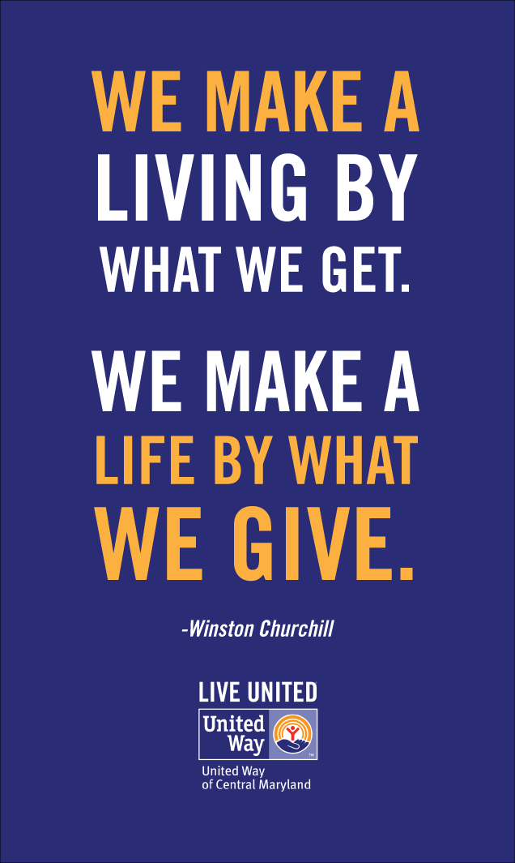

81 Elmwood Way

PO Box 1139

Waynesville, NC 28786

828-356-2832

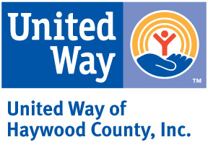

MEMBER AGENCIES

Big Brothers Big Sisters Haywood Christian Ministry

Clothes to Kids Mountain Projects, Inc.

Daniel Boone Council -Safe at Home

Haywood County 4-H -Foster Grandparent/-

Haywood Meals on Wheels Senior Companions

Haywood Meals on Wheels -Congregate Nutrition/-

Haywood Pathways Center Ensure

HIGHTS, Inc. OnTrack Financial

K.A.R.E. REACH of Haywood County

Lifeworks The Arc of Haywood County

Manna Food Bank The Community Kitchen

Maple Leaf Adult Respite The Salvation Army

*From the Executive Director’s Desk…*United Way of Haywood County exists due to the generosity of donors, volunteers and community leaders. The agencies supported by United Way are making a tremendous impact as they continue to do great things with limited resources. We certainly appreciate your support as we strive together to make Haywood County a better place to live, work and play.

Celesa T. Willett

BOARD OF DIRECTORS

Danielle Wittekind – President

Audrey Gaddis– Secretary

Megan Wyatt – Treasurer

Wesley Allison

Paige Bridges

Devon Bush

Denise Coleman

Jeff Haynes

Summer Lindsay

Holly Rogers

Catherine Weidman-Smirnov

Travis Tallent

Jodi Wijewickrama