* * *

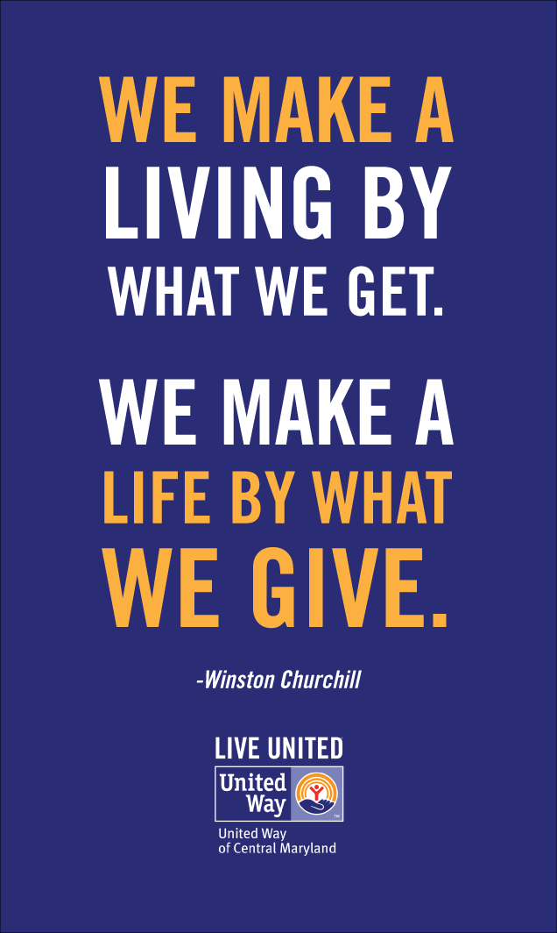

* * *





# 

**BRONZE CIRCLE**

Anthony Anderson

Thomas F. Armstrong

David Belisle

Benjamin Blakely

Alan Burnette

John Boate

John and Jan Chicoine

Fred Clark

Don and Denise Coleman

William T. and Melissa Collins

Randall Conner

Hubert Cooper

Patsy Davis

Josh Deaver

Michael Denman

Michelle Dobson

Audrey and Michael Gaddis

Lee Galloway & Nancy Thompson

Jacob Golden, Jr.

Juliet Greene

Darrell Hedrick

Wendy Hines

Ronald Kidwell

Keith Kornegay

Illia Kryvytskyi

Rex LaRowe

Michael Laughlin

Ron and Laura Leatherwood

Johnny Luther

Tim Massey

Danny Mathis

Daniel Meyer

John and Arlene Mills

Andrew Paul Morgan

Michael and Heather Pless

Jacquelyn Nabors-Wolfe

Bill and Malene Nolte

James Phelan

Scott Ray

Bill and Beth Snyder

Joseph Spivey

James Stamey

Shelley White

Jason R Whitted

Barry and Celesa Willett

Paul Wilson

Anonymous Donors



2021/2022 Leadership Giving Circle

United Way of Haywood County

|  |
| --- |
| **ALEXIS DE TOCQUEVILLE** |
| Chuck and Nancy Beemer  John and Myra Bottoms  Bradford Stanback & |
| Shelli Lodge-Stanback |
| **PLATINUM CIRCLE** |
| Sam and Kathleen Bell  Ross and Sandy Irvine  Joseph Yagatich  Anonymous Donor |
|  |
| **GOLD CIRCLE** |
| Kristen Hammett  Stephen and Annette Hutchins  Max and Susan Kimel  Craig and Laura Linger  Tom and Sally Moore  Maurice and Claire Phillips  Scott Stevens  Laurin Traub  Buddy and Jane Young |
|  |
| **SILVER CIRCLE** |
| Ronald L. Allen  Robin and Tom Batchelor  Everett Baucom  Wilma Scott Boatwright  Ignacio Borges  John and Carolyn Bowers  Nicole Byers  Jason Carr  Larry and Brenda Clark  Ronald P. Clauser  Benjamin Easter  Nicole Ethridge  Traci Fisher  Ken Gilligan  Dianne Goodgame  Fady Gorges  Anthony Hewitt  Robert Hites, Jr.  Anne Irvine  Carol Kashmer  Rolf Kaufman  Mrs. Frances A Killian  Larry and Julie Leatherwood  George and Marleen Marshall  David and Leah Mehaffey  Patricia Miller  Daniel Newsom  Tom and Patsy Posey, Jr.  Frank G. Queen  Todd Seymour  Ricky and Kathy Sheppard |
| Edward Sosnowski  Daniel Swift  Bill and Treva Upton  Herb and Pat Van der Ven  Aleesa C. Williams  Kenneth and Deborah Wilson  Danielle Wittekind |
|  |

. . .

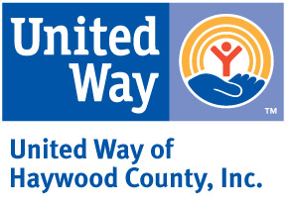

PO Box 1139

Waynesville, NC 28786

Nonprofit

US Postage Paid

Waynesville NC

28786

Permit #57

From the Executive Director’s Desk…What a year has been! Despite the lingering effects of the pandemic and a major flood in our community, the United Way of Haywood County has continued to do good work. The leadership giving list shows those who gave $500 or more to the regular United Way campaign. Many of these same people also gave to the Flood Recovery Fund and we are extremely grateful. Almost $1.4 million has been donated to this fund and we are determined to spend every penny to help those who lost so much. United Way of Haywood County is overwhelmed by the generosity of many individuals and companies who care about our neighbors. “Thank you” seems like such a small thing to say, but we mean it from the bottom of our hearts. Celesa T. Willett

MEMBER AGENCIES

Arc of Haywood County Mountain Mediation Services

Big Brothers Big Sisters Mountain Projects, Inc.

Clothes to Kids -Safe at Home

Daniel Boone Council -Haywood Volunteer

Haywood County 4-H -Foster Grandparent/-Haywood Meals on Wheels Senior Companions

Haywood Pathways Center

HIGHTS, Inc.

K.A.R.E. OnTrack Financial

Lifeworks REACH of Haywood County

Manna Food Bank The Community Kitchen

Maple Leaf Adult Respite The Salvation Army

BOARD OF DIRECTORS

Tara Keilberg – President

Holly Rogers – Vice President

Audrey Gaddis– Secretary

Denise Coleman – Treasurer

Paige Bridges

Rick Chandler

Jeff Haynes

Wendy Hines

Chad McMahon

Ricky Mehaffey

Jeff Schandevel

Walton Shepherd

Danielle Wittekind

Megan Wyatt

Joe Yagatich

|  |  |  |
| --- | --- | --- |
|  | 2021/2022 Annual Report |  |